Functional Programming using filter()
1. Remove Element
class Solution {
public int removeElement(int[] nums, int val) {
int k = 0;

for (int i = 0; i < nums.length; i++) {
if (nums[i] != val) {
nums[k] = nums[i];
k++;
}
}

return k;
}
}
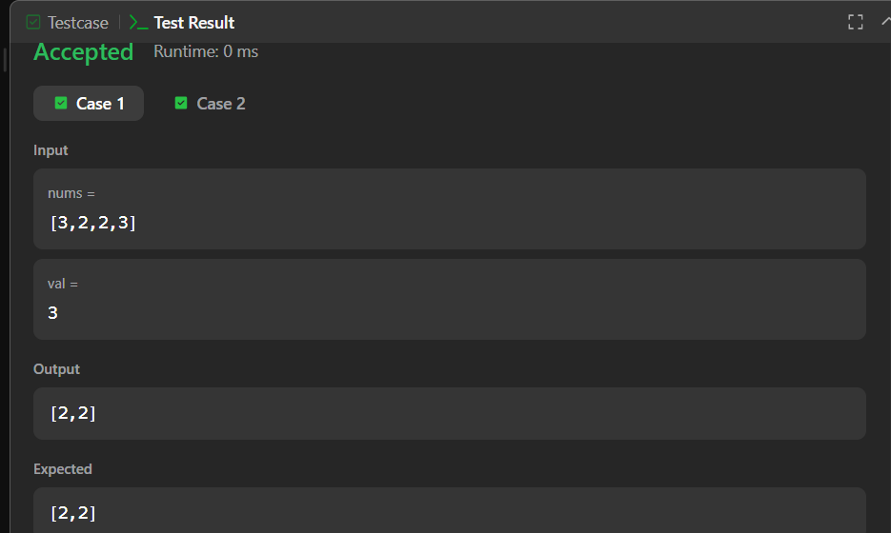
2. Remove Duplicates from Sorted Array:
class Solution {
public int removeDuplicates(int[] nums) {
int k = 1;

for (int i = 1; i < nums.length; i++) {
if (nums[i] != nums[i - 1]) {
nums[k] = nums[i];
k++;
}
}

return k;
}
}